***876741 Awais Afridi***

Q1: Which of the following events will induce *new* firms to enter an industry?

Which will induce firms to exit?

When will entry or exit cease?

Explain your answer.

a) A technological advancement, lowers the fixed cost of production of every firm in the industry.

A fall in the fixed cost of production generates a fall in the average total cost of production and,

in the short run, an increase in each firm’s profit at the current output level. So

in the long run new firms will enter the industry. The increase in supply drives down price and profits. Once profits are driven back to zero, entry will cease.

b) The wages paid to workers in the industry go up for an extended period of time.

An increase in wages generates an increase in the average variable and the average total cost of production at every output level.

In the short run, firms incur losses at the current output level, and so

in the long run some firms will exit the industry. (If the average variable cost rises sufficiently, some firms may even shut down in the short run.) As firms exit, supply decreases, price rises, and losses are reduced. Exit will cease once losses return to zero.

c) A permanent change in consumer tastes increases the demand for the good.

Price will rise as a result of the increased demand, leading to a short-run increase in profits at the current output level.

In the long run, firms will enter the industry, generating an increase in supply, a fall in price, and a fall in profits. Once profits are driven back to zero, entry will cease.

d) The price of a key input rises due to a long-term shortage of that input.

The shortage of a key input causes that input’s price to increase, resulting in an increase in average variable and average total cost for producers. Firms incur losses in the short run, and some firms will exit the industry in the long run. The fall in supply generates an increase in price and decreased losses. Exit will cease when the losses for remaining firms have returned to zero.

Q2: Compare the short-run and the long-run industry supply curves. Which one is flatter? Why?

The short-run supply curve of the industry always slopes upwards to the right, the long-run supply curve may be a horizontal straight line, sloping upwards or sloping downwards depending upon the fact whether the industry in question is a constant cost industry, increasing cost industry or decreasing cost industry. But the long-run upward sloping curve is more typical of the actual world.

Q3: In a competitive market, a firm produces T-shirts and operates with the following cost function:

TC(q)=72+12q+4q2

The market price for T-shirt is P=44

a) Define ATC, AVC, and MC and represent graphically the related curves.

b) Define the optimal quantity the firm will decide to produce.

c) Define the supply curve in the short run and represent it graphically. Which is the minimum level of P which will induce the firm to stay in the market?

d) Suppose that 1000 firms operate in the market for T-shirt, all characterized by the same technology and by the same cost structure. Define the industry supply curve in the short run (int. define first the DIRECT individual firm supply curve and then multiply it by the total number of firms in the market).

a)

c) The whole MC represented is the short-run individual supply curve, as it all stands above AVC. The firm will halt production in the short run only when MC < AVC, that is when P < 12. However, for the firm to be profitable in the long run, P must be at least equal to minimum ATC.

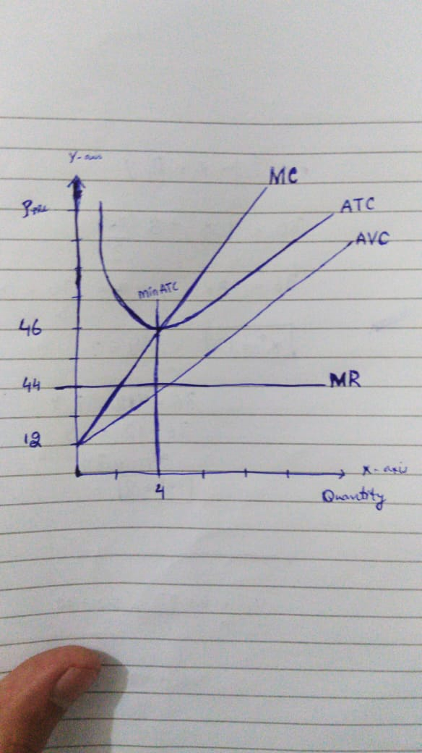

d) Direct individual firm supply curve (equal to MC):

(multiplying by 1000)

Direct industry supply curve:

Q4: Explain why the Average Total Cost Curve is downward sloping for small quantity of output produced and upward sloping for large quantity of output produced.

The higher the FC the higher the AFC, so it is inconvenient for low Q. But the better resources paid with high FC makes it convenient for high Q.



The average total cost curve is U-shaped. Average total cost is relatively high for small quantities of output, then as production increases, it declines, reaches a minimum value, then rises. Because average total cost is a combination of average variable cost and average fixed cost, the U-shape of the average total cost curve is a result of both underlying averages. At small production quantities, both average fixed cost and average variable cost decline, resulting in a negatively-sloped average total cost curve. However, because of the law of diminishing marginal returns, average variable cost eventually increases, which overwhelms the continuing decline of average fixed cost and results in a positively-sloped average total cost curve.